Day #17 – Is this the only course that I need?

Just two days left. Welcome to Day #17.

I hope that over the last 16 days you learned a tremendous amount about the marketplace and how to start making money.

Today we are looking at a few more options out there for people like yourself who may want to accelerate their skills.

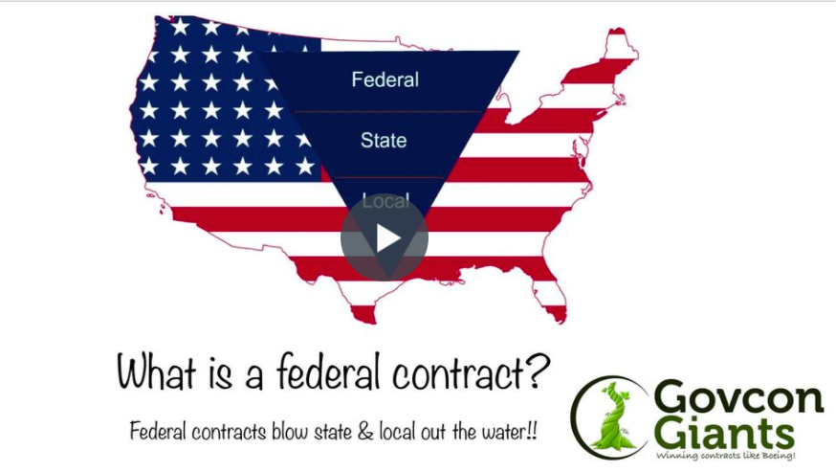
Learn how to take the fast lane now.

- If you are not comfortable bidding jobs.
- If you are not sure how to find clients.
- If you still have questions about maximizing your time?

Watch today’s lesson.

A few more options for everyone

Big hug,

Eric Coffie

